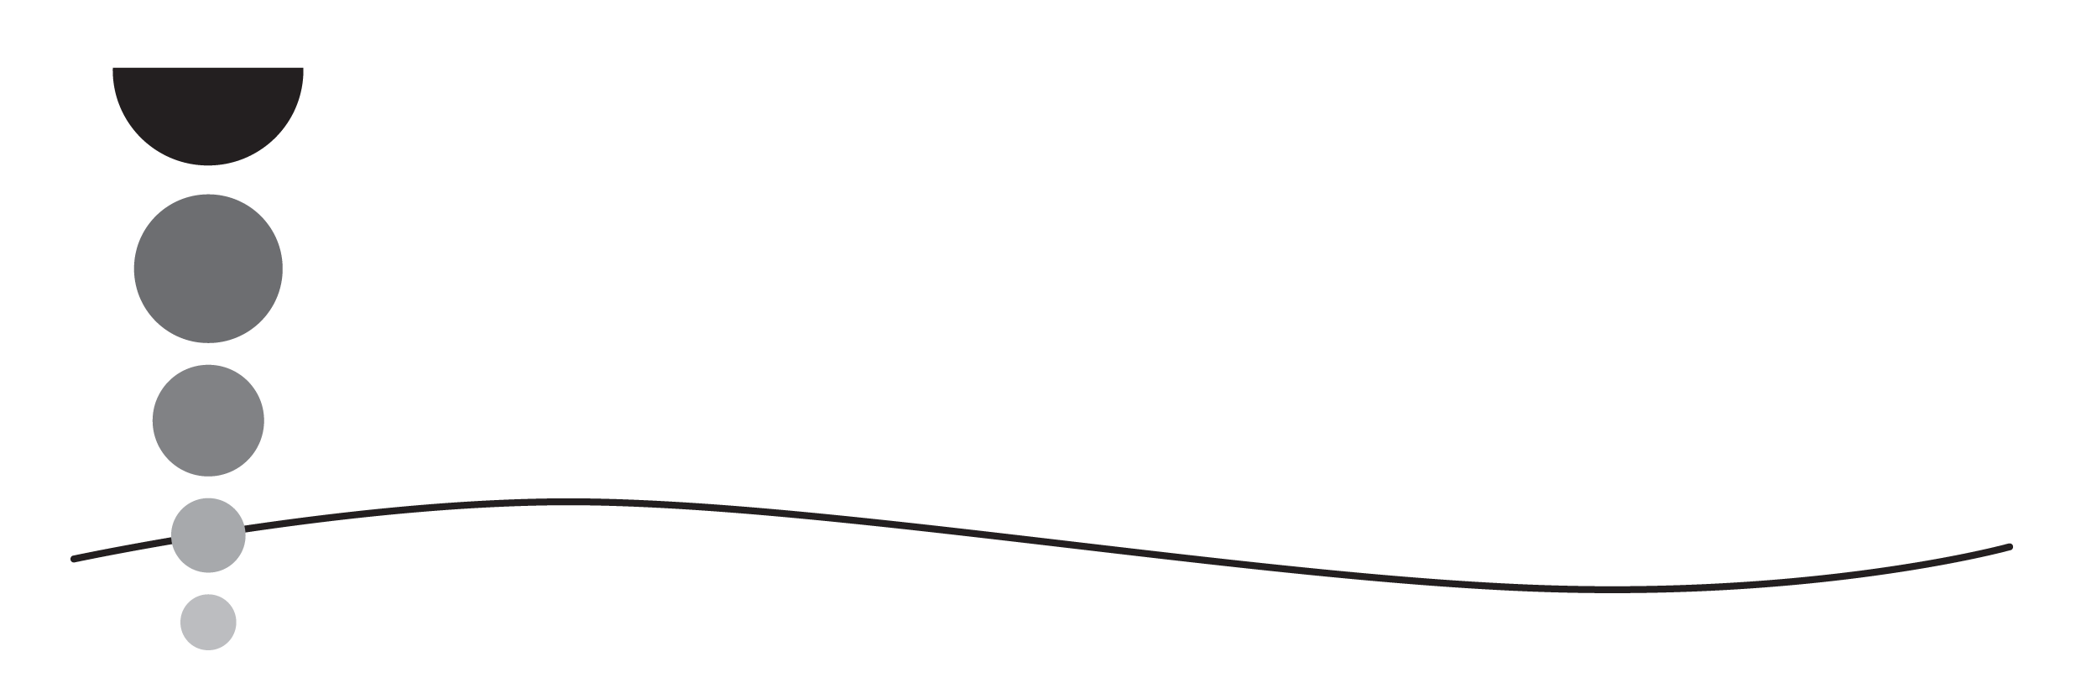

Services for Young Children

Parents don’t miss out!

Free education and childcare for 2-year-olds

Your 2-year-old can get free childcare if you live in England, and you receive any of the following benefits:
- Income Support
- income-based Jobseeker’s Allowance (JSA)
- income-related Employment and Support Allowance (ESA)
- Universal Credit, and your household income is £15,400 a year or less after tax, not including benefit payments
- the guaranteed element of Pension Credit
- Child Tax Credit, Working Tax Credit (or both), and your household income is £16,190 a year or less before tax
- the Working Tax Credit 4-week run on (the payment you get when you stop qualifying for Working Tax Credit)
2-year-olds can also get free childcare if they:
- are looked after by a local authority
- have an education, health and care (EHC) plan
- get Disability Living Allowance
- have left care under an adoption order, special guardianship order or a child arrangements order
You may have to pay for extra costs like meals, nappies or trips.
If your immigration status says you have ‘no recourse to public funds’, you may still get free childcare for your 2-year-old. See here for details: Help paying for childcare: Free education and childcare for 2-year-olds - GOV.UK (www.gov.uk)
For further details and to apply
The free offer starts the term after your child is 2. To find out more visit Free Early Years Education (EYE) funding for eligible 2 year olds | Children and Families | Hampshire County Council (hants.gov.uk) or speak to your childcare provider.

