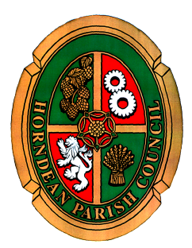

POWE POWERS AND DUTIES OF STANDING COMMITTEES

Subject to the foregoing, and to observance of decisions of the Council on matters of principle or policy, all the Council's powers and duties shall be delegated to the Standing Committees in accordance with the following terms of reference unless otherwise specified.

The acts and proceedings of a Committee shall:

(a) Where they are delegated to the Committee, so far as is legally permissible be deemed the acts and proceedings of the Council;

(b) As regards other matters, be subject to confirmation by the Council, and when confirmed shall be deemed the acts and proceedings of the Council;

(c) In all respects be subject to the provisions of the determined by the Council.
Council's Standing Orders and Financial Regulations except as otherwise

The Council may at any time without prejudice to executive action already taken revoke any executive power delegated to a Committee.

PLANNING AND PUBLIC SERVICES COMMITTEE

(a) The making of representations to the Local Planning Authority on applications for planning permission which have been notified in accordance with relevant legislation;

(b) The making of representations in respect of appeals against the refusal of planning permission;

(c) The making of recommendations regarding street naming;

(d) To consider and monitor strategic, County, District and other developmental plans, which impact upon the Parish, and the making of all appropriate representations.

(e) The facilitation of economic development initiatives for the benefit of the Parish and the making of recommendations on all related matters and liaison as appropriate with other agencies;

(f) The making of representations to the appropriate Planning Authority in respect of other planning matters not otherwise referred to in Terms of Reference (a) - (e) above.

(g) The making of representations to the appropriate authority in respect of highways matters.

(h) The making of representations to the appropriate authority in respect of public transport services.

(i) The making of representations to the appropriate authority in respect of all health care/service matters.

(j) The making of representations to Hampshire Police Authority in respect of all local policing matters, including the establishment of joint partnership initiatives.

(k) The making of representations to East Hampshire District Council regarding any licensing issues upon which a Parish Council view/recommendation is being sought.

(l) All other matters which are the responsibility of other local authorities/external agencies and directly affect the parish, its residents, and/or basic infrastructure.

DELEGATION TO CHAIRMEN GENERALLY

To cancel or postpone a meeting, owing to lack of business, or in the event of an emergency.

