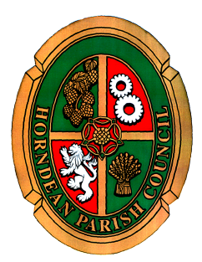

Horndean Parish Council

NOTICE OF MEETING

AN EXTRAORDINARY MEETING OF HORNDEAN PARISH COUNCIL WILL BE HELD MONDAY 22 APRIL 2024 AT 06.30 P.M IN JUBILEE HALL.

Members are summoned to attend

Cllr John Lay
Chairman of the Council

17 April 2024

AGENDA

- To receive apologies for absence.

- To receive any Declarations of Interest.

- To open the meeting to members of the public to enable them to address questions to Parish Councillors. The period of time which is designated for public participation shall not exceed 20 minutes. Each member of the public is entitled to speak once only in respect of business itemised on the agenda and shall not speak for more than 3 minutes. A question asked by a member of public during public participation session may be answered at a meeting or in writing following the meeting and shall not require a debate.

- To receive and consider the design submission and appoint the contractor to complete the works at Jubilee Play Area.

