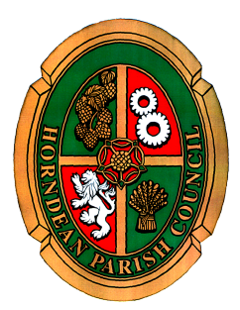
Horndean Parish Council

NOTICE OF MEETING

A MEETING OF THE GROUNDS COMMITTEE WILL BE HELD ON MONDAY
25 MARCH 2024 AT 7.00pm in Jubilee Hall.
Members of the Committee Cllr J Lay, Cllr S Freeman (Chairman), Cllr R Sowden, Cllr D Prosser, Cllr A Redding (Vice Chairman), Cllr J Hodgson, Cllr R Smith.
are summoned to attend.
19 March 2024

Carla Baverstock-Jones
Chief Officer
AGENDA
- To receive apologies for absence.
- Declaration of interest: Members are reminded of their responsibility to declare any disclosable pecuniary interest which they may have in any item of business on the agenda no later than when that item is reached. Unless dispensation has been granted, you may not participate in any discussion of, or vote on, or discharge any function related to any matter in which you have a pecuniary interest as defined by regulations made by the Secretary of State under the Localism Act 2011. You must withdraw from the room or chamber when the meeting discusses and votes on the matter.

- To open the meeting to members of the public to enable them to address questions to Parish Councillors. The period of time which is designated for public participation shall not exceed 20 minutes. Each member of the public is entitled to speak once only in respect of business itemised on the agenda and shall not speak for more than 3 minutes. A question asked by a member of public during public participation session at a meeting shall not require a response or debate.

- To receive and approve the Minutes of the Grounds Committee meeting held on Monday 22 January 2024.
- To receive an update in respect of the completed projects/significant works undertaken by the Countryside Team.

- To receive a report and consider the quotations in respect of the replacement notice board at Parsonage Field.

- To review the status of the notice board at Dell Piece.

- To review the quotations received in respect of the surfacing at Downs Park and Deep Dell play areas.

- To receive and consider a complaint in respect of the grazing of cows on Hazleton Common.

- To receive a report and consider a request for the reduction of trees at Teal close.

- To receive a report and consider the way forward in respect of parking on a grass verge at Wagtail Road.

- To receive a report and consider the placement of bee hives on land within the ownership of the Parish Council.

- To resolve to exclude the public and the press, in the view that publicity would prejudice the public interest by reason of the confidential nature of the business or arising out of the business about to be transacted. (Public Bodies (Admissions to meetings) Act 1960).
- To receive and approve the Confidential Minutes of the Grounds Meeting held on Monday 22 January 2024.
- To receive an update pertaining to the grass cutting contract and consider the way forward.

