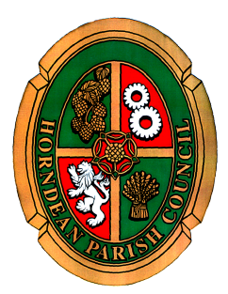
Horndean Parish Council

STAFF COMMITTEE

NOTICE OF MEETING

A MEETING OF THE STAFF COMMITTEE WILL BE HELD ON MONDAY 26 FEBRUARY 2024 AT 6.30 P.M. IN JUBILEE HALL.

Members are summoned to attend.

Carla Baverstock-Jones FSLCC, GCILEx, MCMI
Chief Officer
20 February 2024

AGENDA

- To receive apologies for absence.

- Declaration of interest: Members are reminded of their responsibility to declare any disclosable pecuniary interest which they may have in any item of business on the agenda no later than when that item is reached. Unless dispensation has been granted, you may not participate in any discussion of, or vote on, or discharge any function related to any matter in which you have a pecuniary interest as defined by regulations made by the Secretary of State under the Localism Act 2011. You must withdraw from the room or chamber when the meeting discusses and votes on the matter.

- To receive and approve the Minutes of the meeting held on the 20 November 2023.

- To agree to exclude the public and press, in the view that publicity would prejudice the public interest by reason of the confidential nature of the business or arising out of the business about to be transacted. (Public
Bodies (Admissions to meetings) Act 1960)

- To receive and approve the Confidential Minutes of the meeting held on the 20 November 2023.

- To receive a report and agree the recommendation to Council regarding any proposed changes to staff salaries for 2024/25.

- To discuss any proposed changes to the Chief Officers salary for 2024/25.

