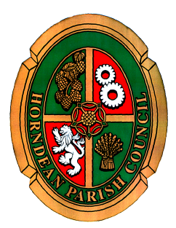

Horndean Parish Council

NOTICE OF MEETING

A MEETING OF THE PLANNING AND PUBLIC SERVICES COMMITTEE WILL BE HELD AT JUBILEE HALL ON MONDAY 14TH MAY 2018 AT 7.45PM.

Members are summoned to attend: Cllr P. Beck(Chairman), Miss J Murray (Vice Chairman), Mrs E. Tickell, Mrs I Weeks, Dr C Jacobs, N. Wren, R Sowden, R Veitch

Carla Baverstock-Jones GCILEx, PSLC
Chief Officer,
8TH May 2018

AGENDA

- To receive apologies for absence.

- Declaration of interest: Members are reminded of their responsibility to declare any disclosable pecuniary interest which they may have in any item of business on the agenda no later than when that item is reached. Unless dispensation has been granted, you may not participate in any discussion of, or vote on, or discharge any function related to any matter in which you have a pecuniary interest as defined by regulations made by the Secretary of State under the Localism Act 2011. You must withdraw from the room or chamber when the meeting discusses and votes on the matter.

- To receive and approve the minutes of the Planning Committee meeting held on 16th April, 2018.

- To open the meeting to members of the public to enable them to address questions to Parish Councillors. Public questions will be permitted for each application as it arises, subject to there being a limit of 3 minutes for any member of the public. A question asked by a member of public during public participation session at a meeting shall not require a response or debate.

- To discuss and note any planning appeals.

- To consider planning applications and note decisions as per attached schedule.
Public questions will be permitted for each application as it arises, subject to there being a limit of 3 minutes for any member of the public.

- To discuss representation of Horndean Parish Council at forthcoming EHDC’s Planning Committee meeting on 31st May 2018.

- To note the date of the next meeting as Monday 4th June 2018.

