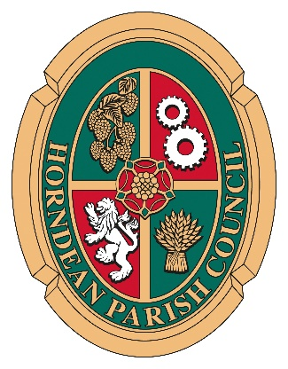
HORNDEAN PARISH COUNCIL

MINUTES OF THE STAFF COMMITTEE MEETING HELD AT JUBILEE HALL ON 4th OCTOBER 2021 AT 6.30 P.M.

PRESENT: Councillors R Veitch (Chairman), Mrs L Evans, A Forbes, P Little, D Prosser (Vice Chairman), Mrs E Tickell

IN ATTENDANCE: Carla Baverstock-Jones, Chief Officer (Minute Taker), Simon Ritson, Responsible Financial Officer

PUBLIC
ATTENDANCE: There were no members of the public present.

SC 008/21/22 TO RECEIVE AND APPROVE APOLOGIES

Apologies of absence were received from Cllr Lay & Mrs I Weeks.

SC 009/21/22 TO RECEIVE ANY DECLARATIONS OF INTEREST

No declarations of pecuniary interest were received.

SC 010/21/22 TO RECEIVE AND APPROVE THE MINUTES OF THE STAFF COMMITTEE MEETING HELD ON THE 05 JULY 2021

It was RESOLVED that the Minutes of the Staff Committee meeting held on 05 July 2021 be signed as a true record of the meeting.

SC 011/21/22 TO RESOLVE TO EXCLUDE THE PUBLIC AND THE PRESS, IN THE VIEW THAT PUBLICITY WOULD PREJUDICE THE PUBLIC INTEREST BY REASON OF THE CONFIDENTIAL NATURE OF THE BUSINESS OR ARISING OUT OF THE BUSINESS ABOUT TO BE TRANSACTED. (PUBLIC BODIES (ADMISSION TO MEETINGS) ACT 1960.

No members of the public or press were present.

Public meeting closed at 18:40PM

SC 012/21/22 TO RECEIVE AND APPROVE THE CONFIDENTIAL MINUTES OF THE MEETING HELD ON THE 05 JULY 2021
It was RESOLVED that the confidential minutes of the Staff Committee meeting held on 05 July 2021 be signed as a true record of the meeting.
SC 013/21/22 TO RECEIVE A REPORT IN RESPECT OF THE FUTURE MANAGEMENT OF JUBILEE HALL

A report was circulated by the Chief Officer who outlined the matters to be considered. A lengthy discussion took place in order for the way forward to be ascertained.

Confidential meeting closed at 19:10PM

………………………………………
Signed - The Chairman

………………………………………
Date

